Order Management System
Project Title: E-Commerce Order Management Database System

Project Title : E-Commerce Order Management Database System
Student Name : Priya M
Register Number : C4S38003
Department : B.Sc Artificial Intelligence
Course : Artificial intelligence (AI)
Academic Year : 2024 – 2027

Order Management System

1. Create Orders Table
CREATE TABLE Orders (
OrderID INT PRIMARY KEY,
CustomerName VARCHAR(50),
OrderDate DATE,
TotalAmount INT
);
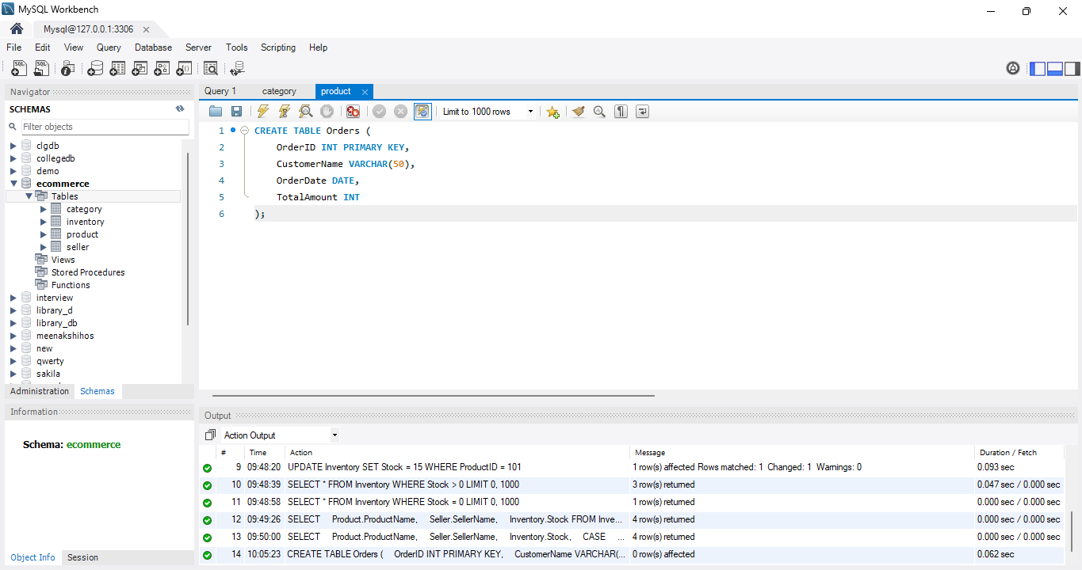

2. Create Order_Details Table
CREATE TABLE Order_Details (
OrderDetailID INT PRIMARY KEY,
OrderID INT,
ProductID INT,
Quantity INT,
FOREIGN KEY (OrderID) REFERENCES Orders(OrderID),
FOREIGN KEY (ProductID) REFERENCES Product(ProductID)
);
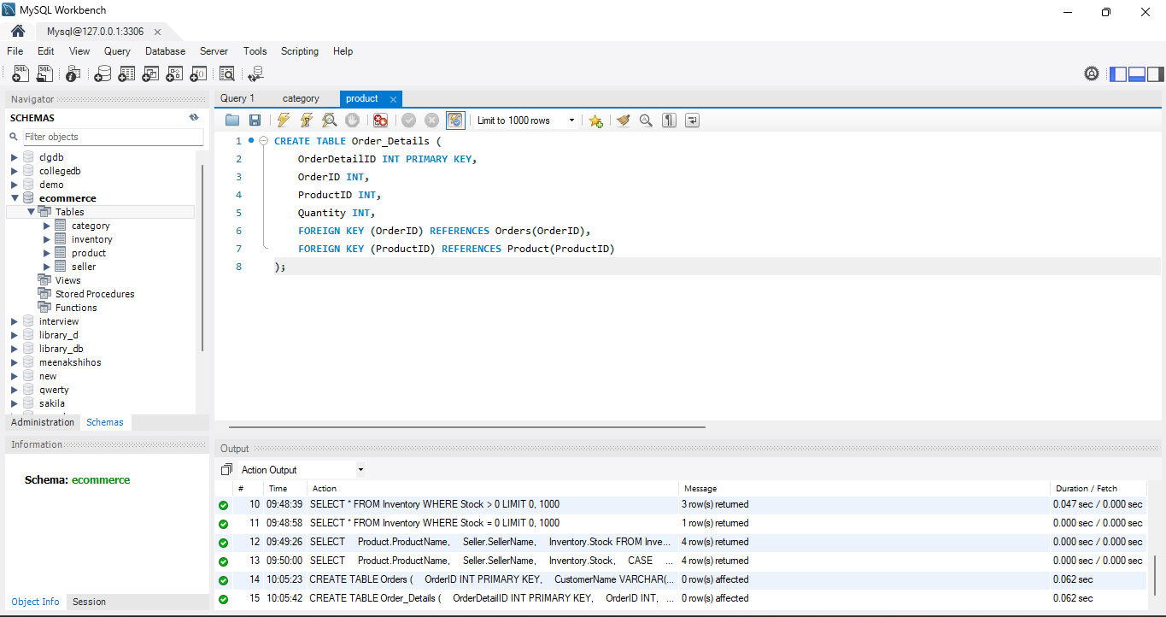

3. Insert Orders
INSERT INTO Orders VALUES
(1, 'Arun', '2026-08-08', 50000),
(2, 'Kumar', '2026-08-08', 20800),
(3, 'Ravi', '2026-08-09', 1600);

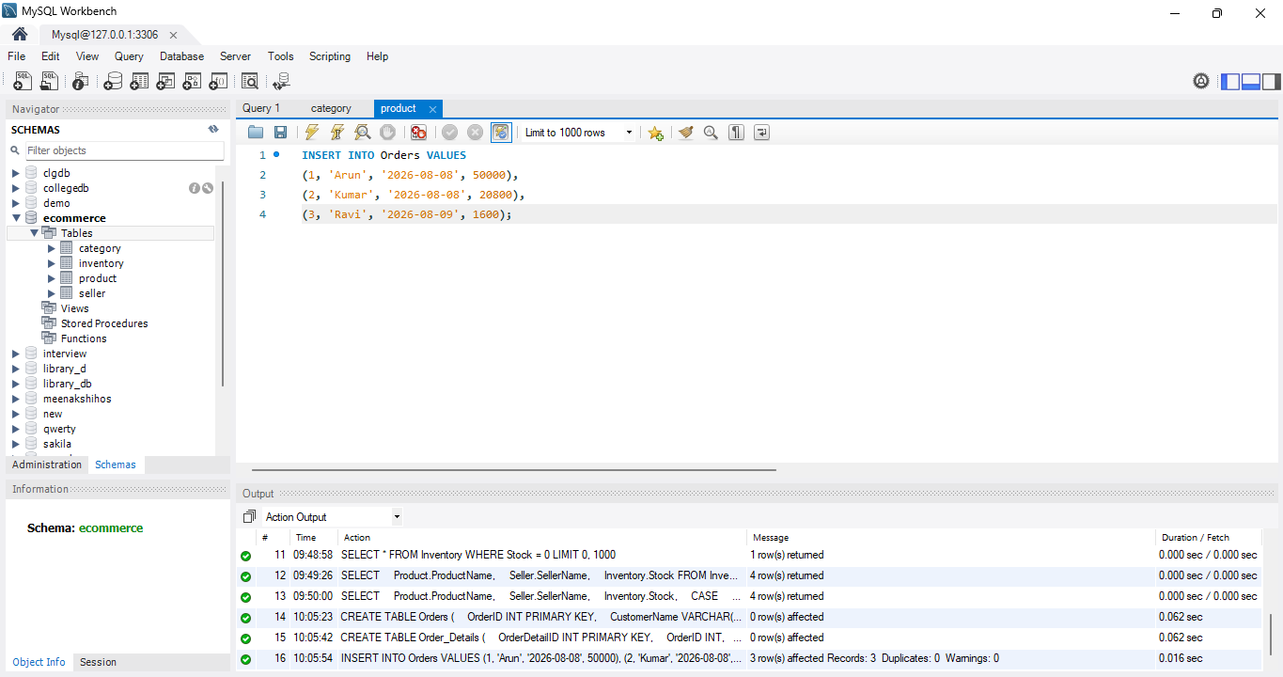

4. Insert Order Details
INSERT INTO Order_Details VALUES
(1, 1, 101, 1),
(2, 2, 102, 1),
(3, 2, 103, 1),
(4, 3, 103, 2);

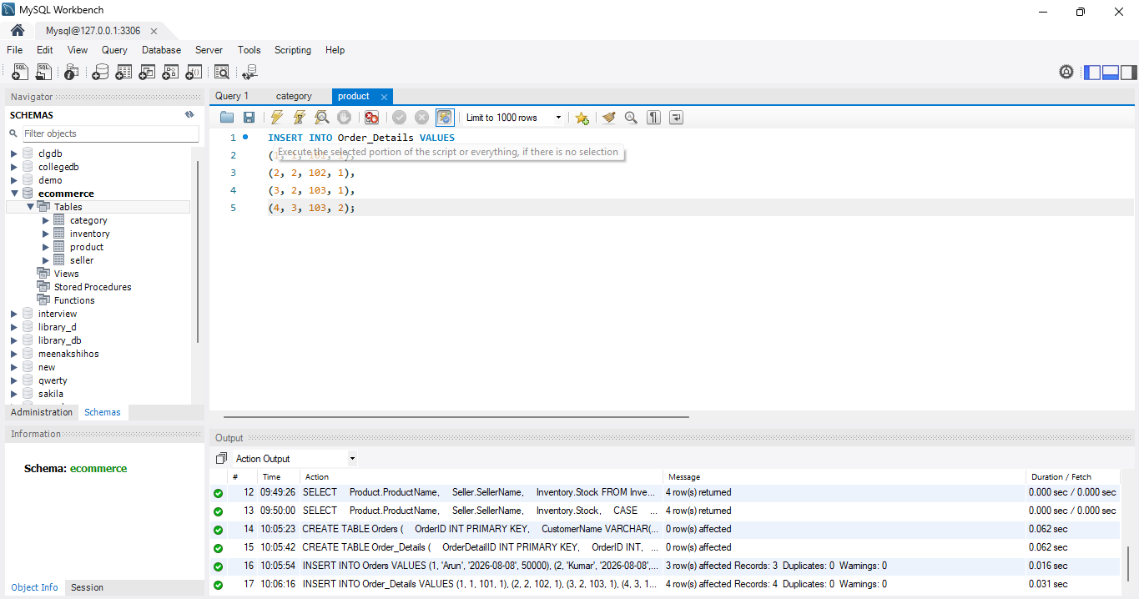

5. Display Orders
SELECT * FROM Orders;
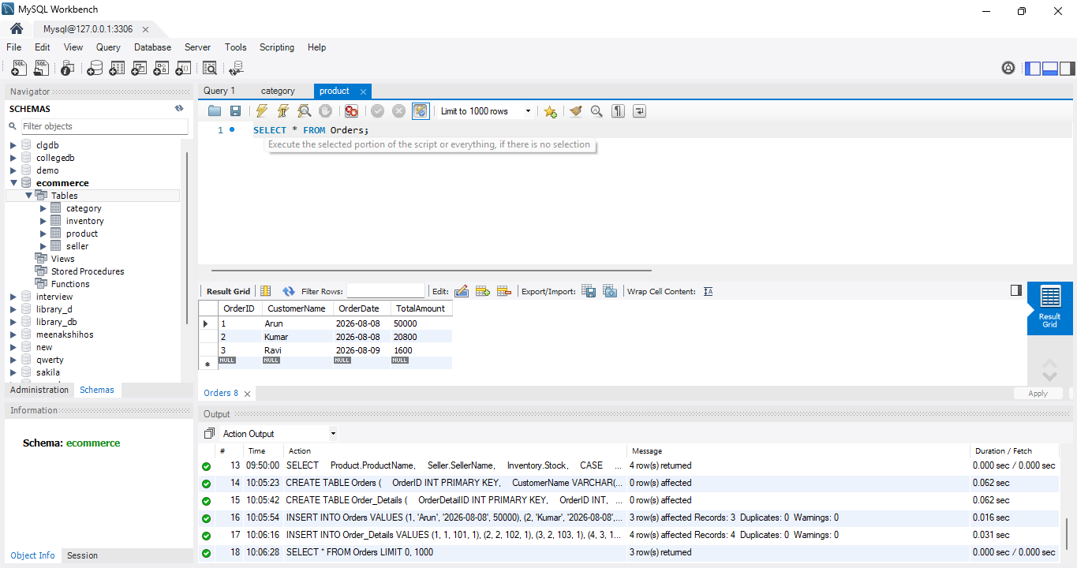

6. Display Order Details
SELECT * FROM Order_Details;
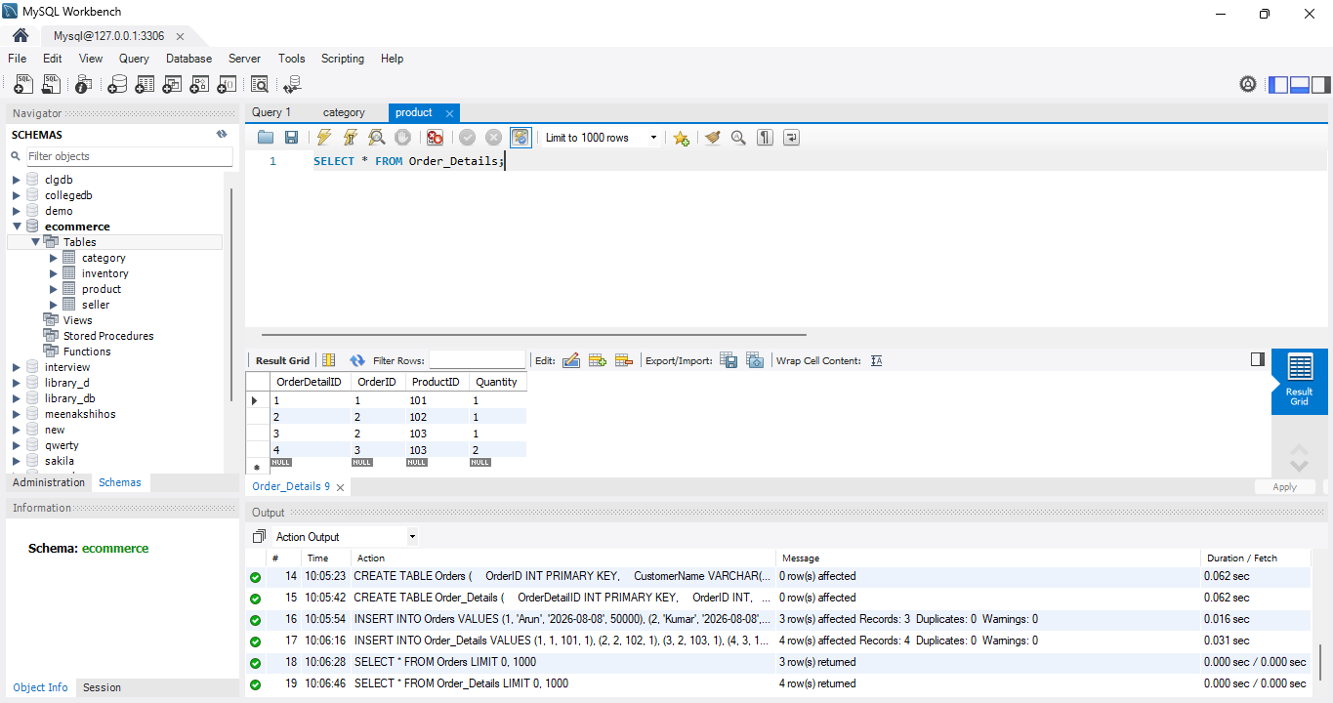

7. Modify Order
For example, change Arun's order amount:
UPDATE Orders
SET TotalAmount = 55000
WHERE OrderID = 1;

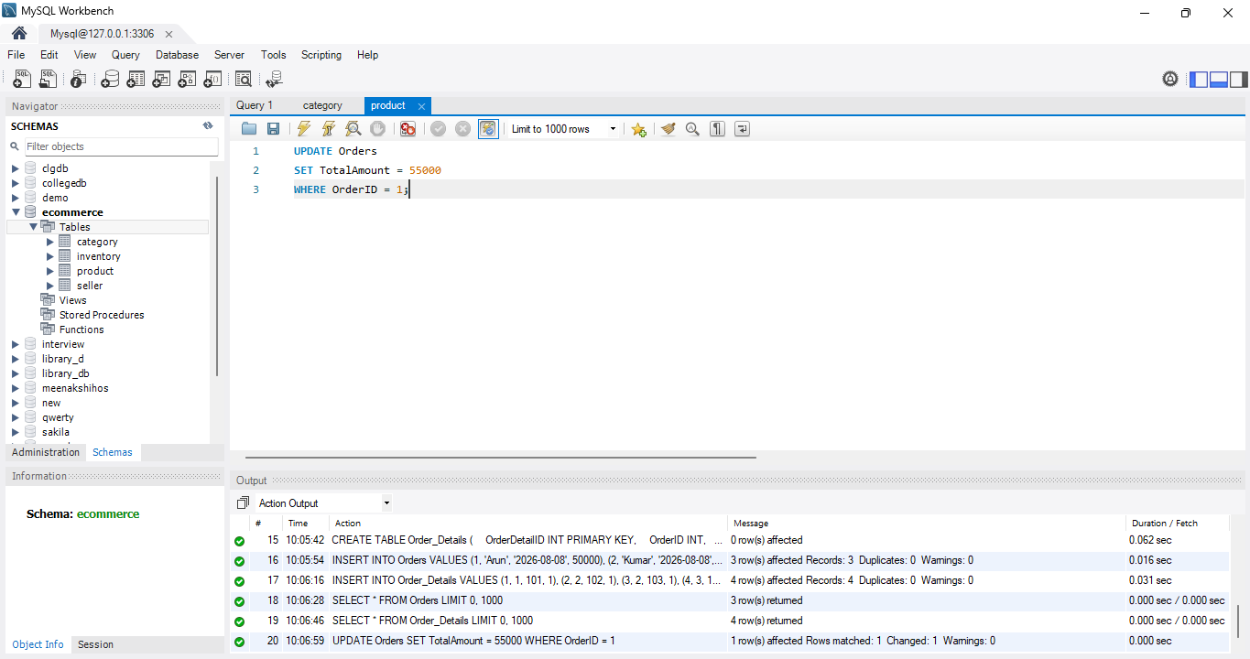

8. Modify Quantity
UPDATE Order_Details
SET Quantity = 2
WHERE OrderDetailID = 1;

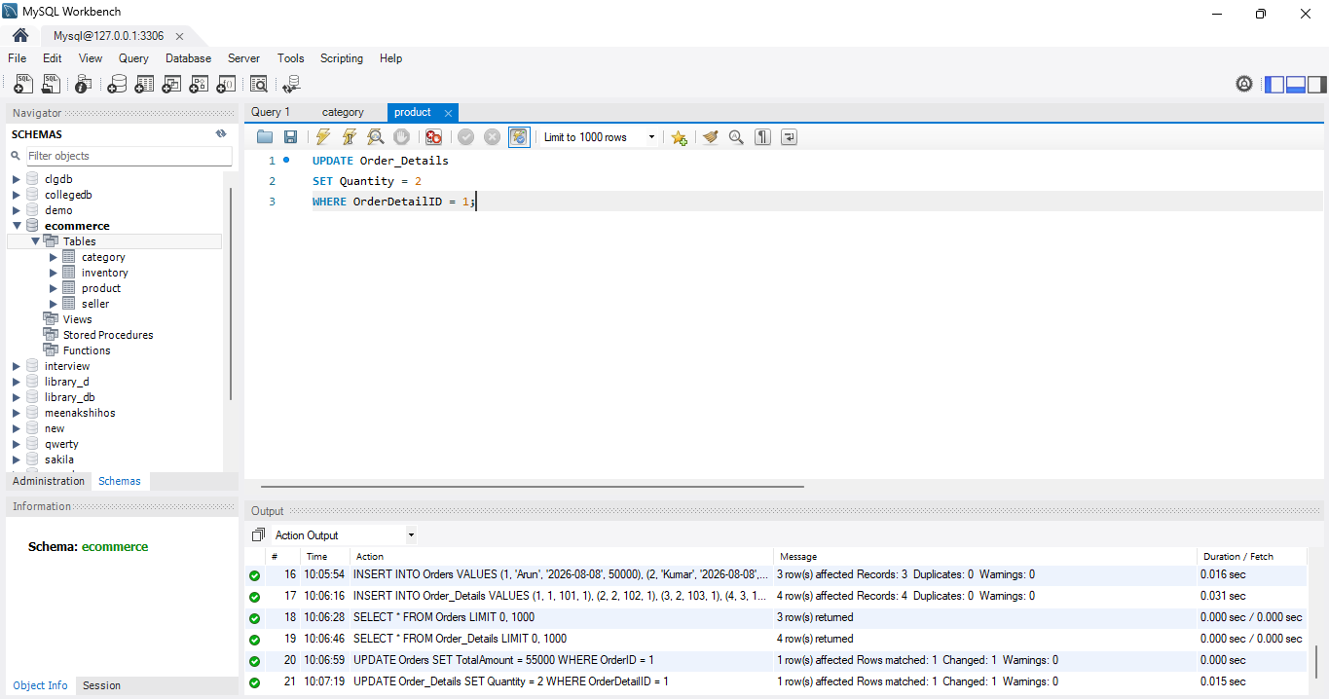

9. Customer Order History Report
SELECT
Orders.CustomerName,
Orders.OrderDate,
Product.ProductName,
Order_Details.Quantity,
Orders.TotalAmount
FROM Orders
JOIN Order_Details
ON Orders.OrderID = Order_Details.OrderID
JOIN Product
ON Order_Details.ProductID = Product.ProductID;

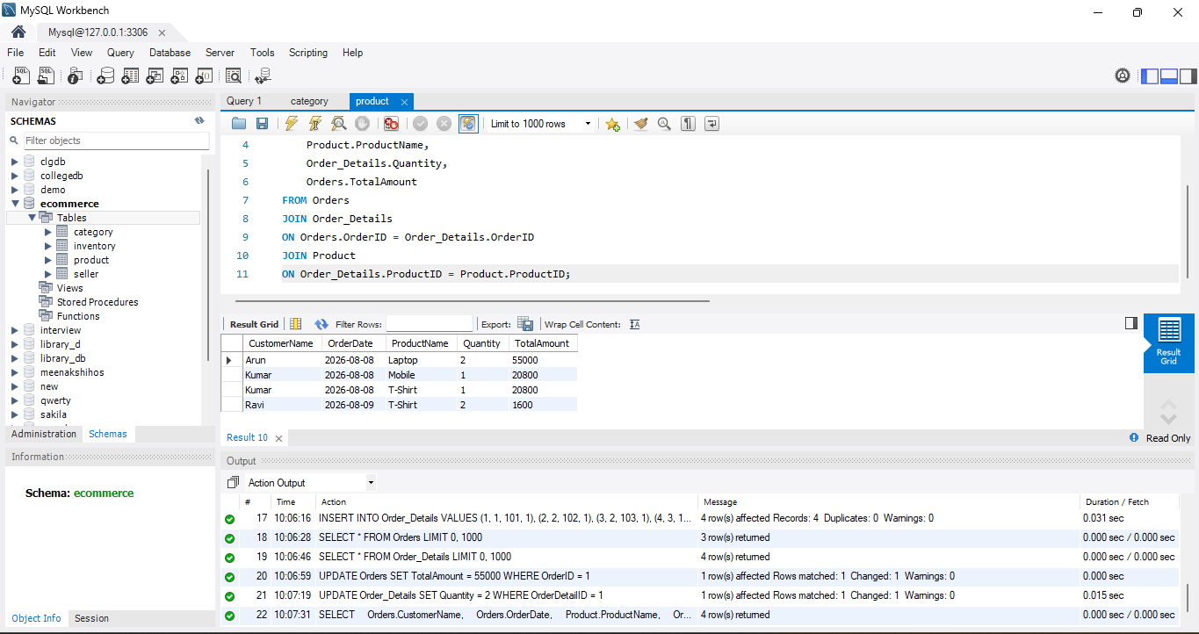

10. Find Orders of a Particular Customer
SELECT *
FROM Orders
WHERE CustomerName = 'Kumar';

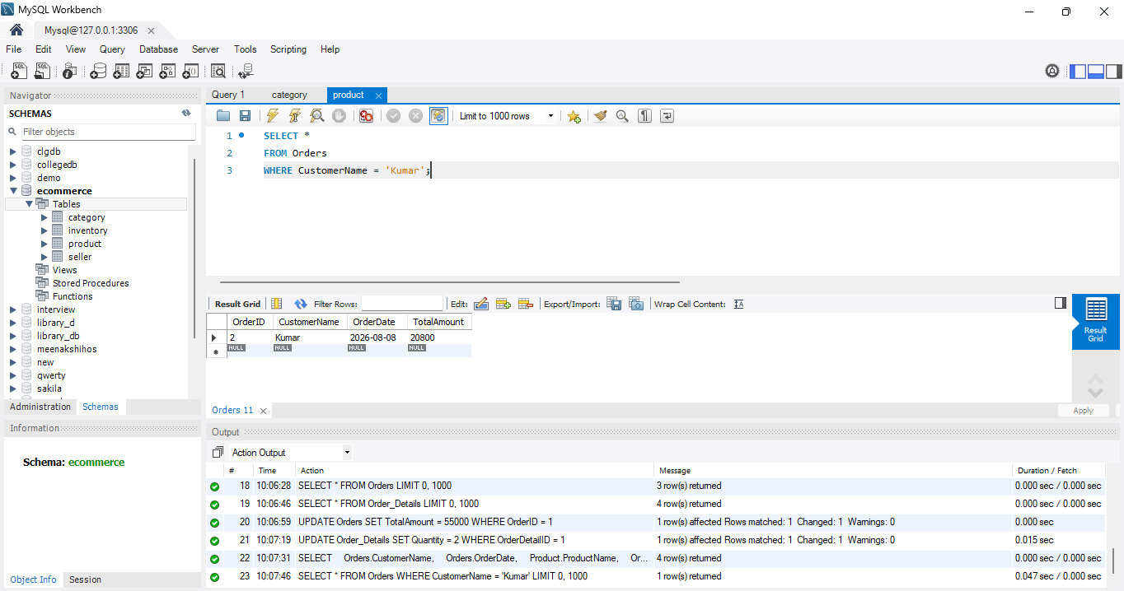

11. Find Order Details of a Particular Order
SELECT *
FROM Order_Details
WHERE OrderID = 2;

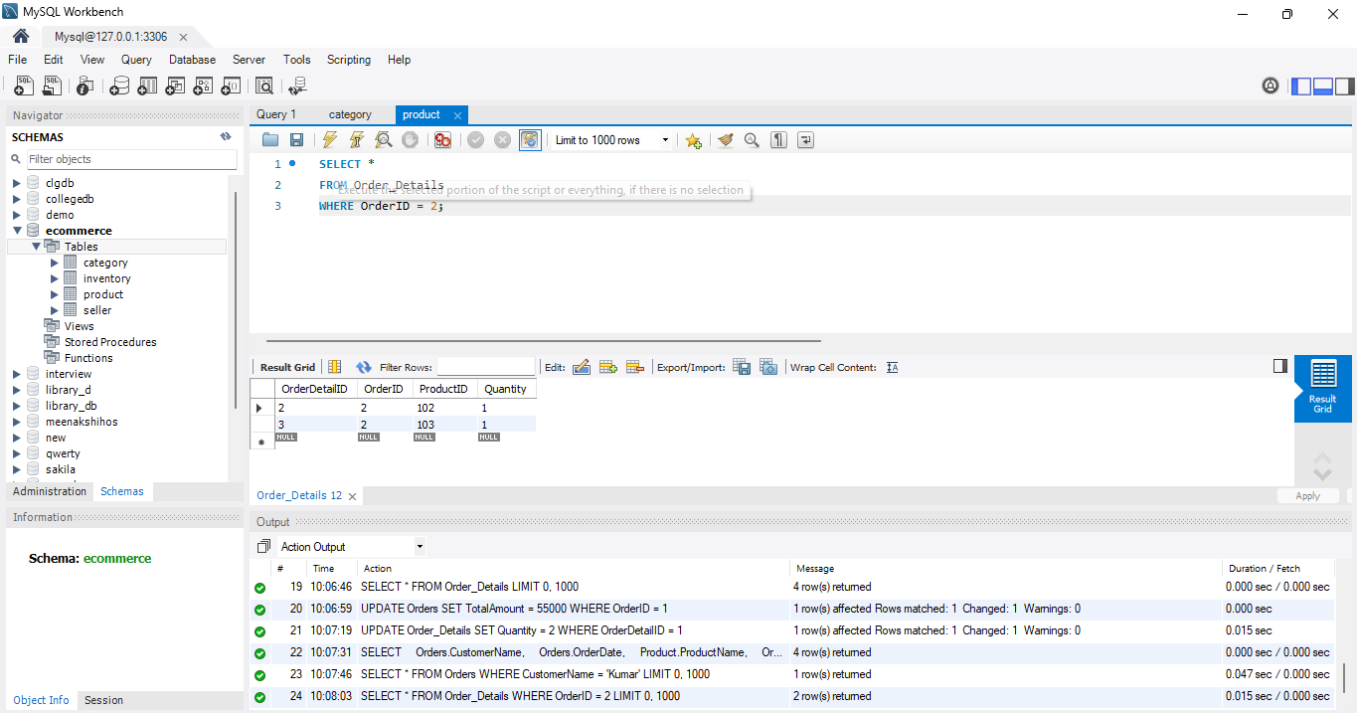

Order Management System
Project Title: E-Commerce Order Management Database System

Project Title : E-Commerce Order Management Database System
Student Name : Anu sri R
Register Number : C4S38001
Department : B.Sc Artificial Intelligence
Course : Artificial intelligence (AI)
Academic Year : 2024 – 2027

Order Management System

1. Create Orders Table
CREATE TABLE Orders (
OrderID INT PRIMARY KEY,
CustomerName VARCHAR(50),
OrderDate DATE,
TotalAmount INT
);


2. Create Order_Details Table
CREATE TABLE Order_Details (
OrderDetailID INT PRIMARY KEY,
OrderID INT,
ProductID INT,
Quantity INT,
FOREIGN KEY (OrderID) REFERENCES Orders(OrderID),
FOREIGN KEY (ProductID) REFERENCES Product(ProductID)
);


3. Insert Orders
INSERT INTO Orders VALUES
(1, 'Arun', '2026-08-08', 50000),
(2, 'Kumar', '2026-08-08', 20800),
(3, 'Ravi', '2026-08-09', 1600);



4. Insert Order Details
INSERT INTO Order_Details VALUES
(1, 1, 101, 1),
(2, 2, 102, 1),
(3, 2, 103, 1),
(4, 3, 103, 2);



5. Display Orders
SELECT * FROM Orders;


6. Display Order Details
SELECT * FROM Order_Details;


7. Modify Order
For example, change Arun's order amount:
UPDATE Orders
SET TotalAmount = 55000
WHERE OrderID = 1;



8. Modify Quantity
UPDATE Order_Details
SET Quantity = 2
WHERE OrderDetailID = 1;



9. Customer Order History Report
SELECT
Orders.CustomerName,
Orders.OrderDate,
Product.ProductName,
Order_Details.Quantity,
Orders.TotalAmount
FROM Orders
JOIN Order_Details
ON Orders.OrderID = Order_Details.OrderID
JOIN Product
ON Order_Details.ProductID = Product.ProductID;



10. Find Orders of a Particular Customer
SELECT *
FROM Orders
WHERE CustomerName = 'Kumar';



11. Find Order Details of a Particular Order
SELECT *
FROM Order_Details
WHERE OrderID = 2;



